Weekly Work Report 6/14/2024

**This Week:**

1. **Summary Table for Previous Results**





1. **Working on the EEG Dataset**
   1. Literature **Review:**
      1. Chaddad, A., Wu, Y., Kateb, R., & Bouridane, A. (2023). Electroencephalography Signal Processing: A Comprehensive Review and Analysis of Methods and Techniques. Sensors, 23(14), 6434
      2. H. Cheng, M. Wang, C. Ma and C. Yu, "A Review of Brain Information Processing for Robot Control," 2022 7th International Conference on Image, Vision and Computing (ICIVC), Xi’an, China, 2022, pp. 866-871, doi: 10.1109/ICIVC55077.2022.9886157.

* **The characteristics of EEG signals**

1. **Signal Non-linearity:**
   * EEG signals exhibit non-linearity, activeness, and time-varying causality. They represent a complex, dynamic system with non-linear behavior.
   * This complexity arises from the interactions of neural populations, synaptic activity, and various physiological processes.
2. **Weakness of Signal:**
   * Normal EEG signals are indeed weak. The spontaneous EEG potential in the human body typically ranges between 2 µV and 75 µV.
   * EEG generated during mental activities (such as thinking or feeling) is even weaker, usually falling within the 2 to 10 µV range.
   * Detecting such subtle signals amidst spontaneous EEG noise can be challenging.
3. **Small Frequency Range:**
   * The frequency range of human brain electricity (EEG) typically spans from 0.5 Hz to 40 Hz.
   * Different frequency bands (e.g., delta, theta, alpha, beta, and gamma) convey specific information about brain states and cognitive processes.
4. **Strong Noise:**
   * EEG signals are often contaminated with various types of noise. Common sources include power frequency interference (such as 50 or 60 Hz), white noise, and spikes.
   * Additionally, EMG (electromyography) and ECG (electrocardiography) artifacts can also be present.
5. **Randomness and Non-Stationarity:** 
   * EEG signals exhibit strong randomness and non-stationarity. Due to complex factors (such as changes in brain activity, electrode placement, and external influences), EEG signals continuously vary without a clear pattern.
6. **Frequency Domain Characteristics:**
   * **The frequency domain analysis of EEG signals reveals important features.** For instance, the power spectrum can highlight dominant frequency components, such as alpha, beta, theta, and delta waves.

* **EEG frequency 5 bands**

**

Surprise, Attention, engagement, combination.

* **EEG preprocessing methodology**

1. **EEG Signal Filtering and Re-sampling**:

* Filtering: Involves removing unwanted noise or frequency components from EEG signals using techniques like bandpass, low-pass, or high-pass filters.
* Re-sampling: Adjusts the sampling rate of EEG data to a desired frequency.

1. **EEG Signal Decomposition:**

* Decomposes EEG signals into their constituent components (e.g., independent components) using methods like Independent Component Analysis (ICA) or Principal Component Analysis (PCA).

1. **EEG Signal Processing with Graphic User Interface (GUI)**:

* Utilizes user-friendly interfaces to perform various EEG processing tasks, such as artifact removal, feature extraction, and visualization.

1. **Signal Cutting – EEG**:

* Involves segmenting long EEG recordings into shorter epochs for further analysis. Useful for event-related studies.

1. **EEG Processing in BCI System**:

* Applies EEG preprocessing techniques within Brain-Computer Interface (BCI) systems, which allow direct communication between the brain and external devices.
* **Purpose, advantages, and disadvantages of EEG preprocessing methods**
* Purpose

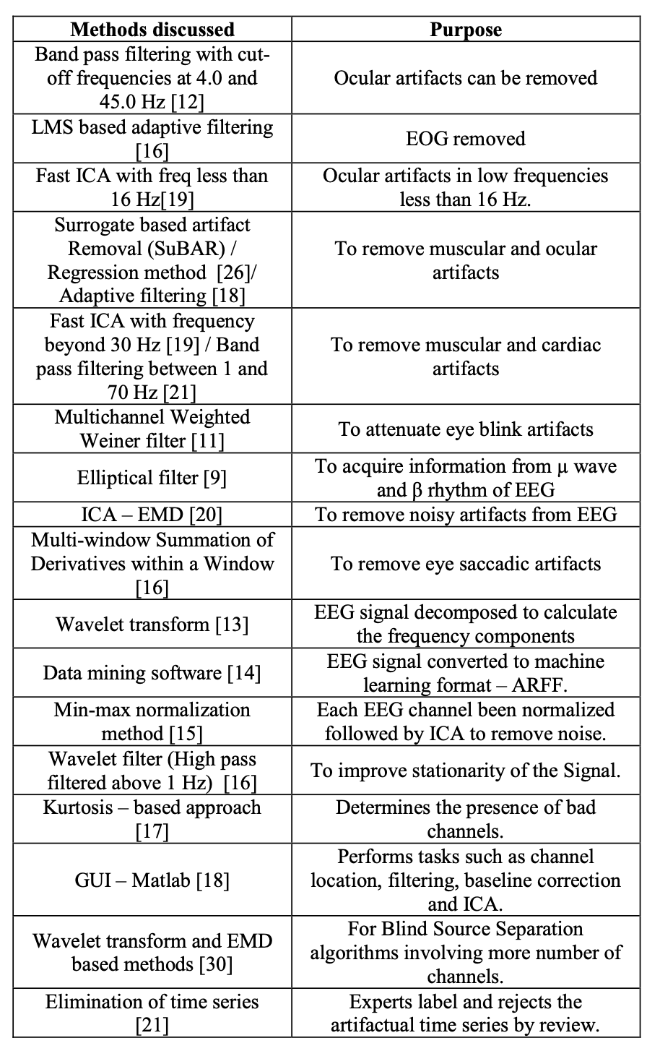

* Advantages vs. Disadvantages

* **EEG signal feature extraction algorithm**

* **EEG signal feature classification algorithm**

1. **Implementing EEG preprocessing methods described in the paper**

* **EEG Signal Filtering and Re-sampling (Python):**

import brainflow

from brainflow.data_filter import DataFilter, FilterTypes, AggOperations

# Initialize the data processing module

BoardShim = brainflow.BoardShim(64, brainflow.BrainFlowInputParams())

BoardShim.enable_dev_board_logger()

# Read the data from the CSV file

data = df.values.T

# Set the sampling rate

sampling_rate = 500

# Create a DataFilter object

DataFilter.perform_lowpass(data, sampling_rate, 50.0, 2, FilterTypes.BUTTERWORTH.value)

DataFilter.perform_highpass(data, sampling_rate, 1.0, 2, FilterTypes.BUTTERWORTH.value)

* **EEG Signal Processing with Graphic User Interface (GUI – MATLAB)**:
  + EEG Preprocessing in EEGLAB

**Next Week:**

* Literature Review on EEG Signal Features
* Schedule a Meeting with Wiam and Gai to Discuss EEG Signal Noise Reduction and Feature Extraction
* Continue EEG data preprocessing
* Perform Data Extraction for WMC